H.T No
Regulations:
A18

Sreenidhi Institute of Science and Technology
(An Autonomous Institution)
Code No: 7A714 Date: 21-Dec-2022 (AN)

B.Tech IV-Year I- Semester (A18) Special Supplementary Examination - December-2022
POWER SYSTEM ANALYSIS AND CONTROL (EEE)

Time: 3 Hours Max.Marks:70

Note: a) No additional answer sheets will be provided.
b) All sub-parts of a question must be answered at one place only, otherwise it will not be valued.
c) Missing data can be assumed suitably.

ANSWER ANY 5 OUT OF 8 QUESTIONS. EACH QUESTION CARRIES 14 MARKS.

Bloom's Cognitive Levels of Learning (BCLL)
Remember | L1 | Apply | L3 | Evaluate | L5
Understand | L2 | Analyze | L4 | Create | L6

 |  |  | BCLL | CO(s) | Marks
1. | a) | Find Y_{BUS} for a network with following data by direct inspection method. Line  impedance and line charging data: | L5 | CO1 | [7M]
  Line  (bus to bus) | Impedance | Line charging  (Y/2)
  1-2 | 0.02 + j 0.1 | j 0.03
  1-5 | 0.05 + j 0.25 | j 0.02
  2-3 | 0.04 + j 0.2 | j 0.025
  2-5 | 0.05 + j 0.25 | j 0.02
  3-4 | 0.05 + j 0.25 | j 0.02
  3-5 | 0.08 + j 0.4 | j 0.01
  4-5 | 0.10 + j 0.5 | j 0.075
 | b) | Discuss the advantage and disadvantages of finding Y_{BUS} by singular transformation. | L3 | CO1 | [7M]
2. | a) | Obtain the mathematical modeling of speed governing system. | L5 | CO2 | [7M]
 | b) | Obtain the transfer function and block diagram representation of First order turbine model. | L5 | CO2 | [7M]
3. | a) | Derive the expression for analysis of integral control for steady state response. | L5 | CO3 | [7M]
 | b) | Develop the block diagram model of uncontrolled two area load frequency control system. | L5 | CO3 | [7M]
4. | a) | Write the assumptions of fast decoupled load flow method. | L4 | CO4 | [7M]
 | b) | With the help of a neat flow chart, explain the Newton-Raphson method of load flow solution. | L4 | CO4 | [7M]
5. | a) | Define steady state stability and Explain the methods for improving steady state stability. | L3 | CO5 | [7M]
 | b) | What is the equal area criterion? Explain how it is useful for predicting system stability. | L4 | CO5 | [7M]
6. | a) | In a thermal power station, incremental costs are given by the following equations:  dc1/dp1 = Rs. (0.15P₁ + 12);  dc3/dp3 = Rs. (0.21P₃ + 13);  dc2/dp2 = Rs. (0.05P₃ + 14);  Where P₁, P₂ and P₃ are the loads in MW. Determine the economical load allocation between the three units, when the total load on the station is 300MW. [5+5] | L4 | CO6 | [7M]
 | b) | Derive the transmission loss formula for a system consisting of n-generating plants supplying several loads inter connected through a transmission networks. | L4 | CO6 | [7M]
7. | a) | Find the bus incidence matrix for the following network?  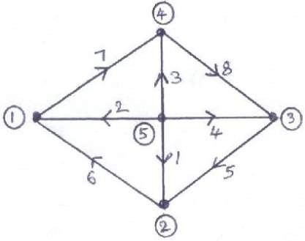 | L3 | CO1 | [5M]
 | b) | For a single area system, show that the static error frequency can be reduced to zero . | L4 | CO2 | [5M]
 | c) | Develop the block diagram model of controlled two area load frequency control system. | L4 | CO3 | [4M]
8. | a) | Compare G-S method and N- R methods of load flow solutions. | L3 | CO4 | [5M]
 | b) | Discuss the various factors affecting the transient stability of the system. | L4 | CO5 | [5M]
 | c) | What is hydro-thermal scheduling? | L3 | CO6 | [4M]
-- 00 -- 00 –

